Editing and Reading Data from Files – Reading and Writing Files in R
Programming
Name: Savitha R
Reg.No: 192421368

R provides several functions to read, write, and edit data from various file formats. This is
essential for data analysis, preprocessing, and reporting.

1. Reading Data from Files
--------------------------
R can read multiple file types:
1. Reading CSV Files:
data &lt;- read.csv(&quot;file.csv&quot;, header = TRUE)
output:

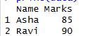

2. Reading Text Files:
data &lt;- read.table(&quot;file.txt&quot;, header = TRUE, sep = &quot;\t&quot;)
output:

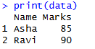
3. Reading Excel Files:
library(readxl)
data &lt;- read_excel(&quot;file.xlsx&quot;)
output:

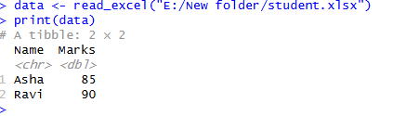
4. Reading RDS Files:
data &lt;- readRDS(&quot;file.rds&quot;)
output:

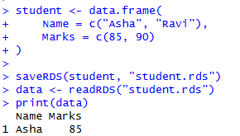

5. Reading JSON Files:
library(jsonlite)
data &lt;- fromJSON(&quot;file.json&quot;)

output:
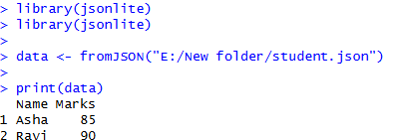

2. Writing Data to Files

1. Writing CSV Files:
write.csv(data, &quot;output.csv&quot;, row.names = FALSE)
output:
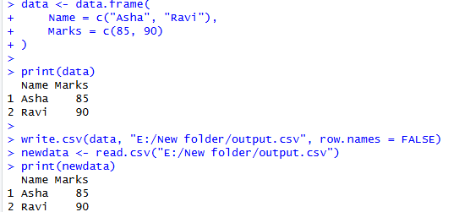

2. Writing Text Files:
write.table(data, &quot;output.txt&quot;, sep = &quot;\t&quot;, row.names = FALSE)
output:
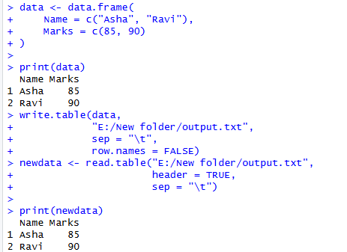

3. Writing Excel Files:
library(writexl)
write_xlsx(data, &quot;output.xlsx&quot;)
output:
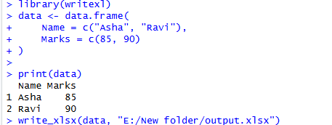

4. Writing RDS Files:
saveRDS(data, &quot;output.rds&quot;)
output:
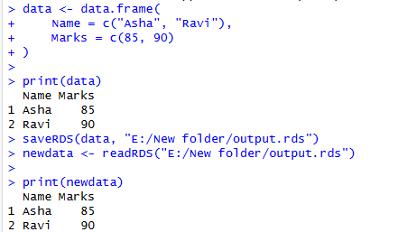
5. Writing JSON Files:
library(jsonlite)
write_json(data, &quot;output.json&quot;)
output:
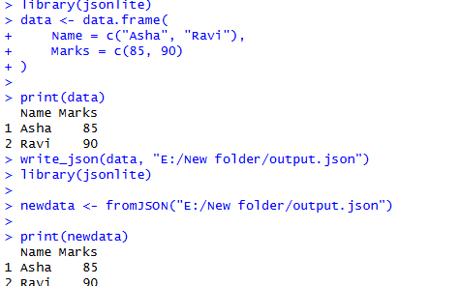

3. Editing Data in R
--------------------
Editing data involves modification using R functions:

- Adding Columns:
data$new_col &lt;- c(1,2,3)
output:
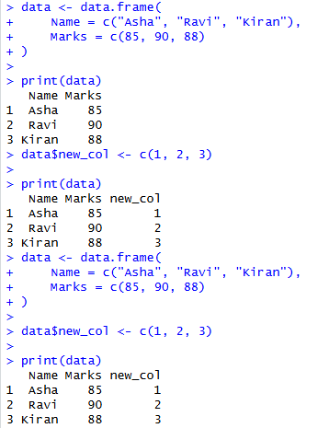

- Removing Columns:
data$col &lt;- NULL
output:
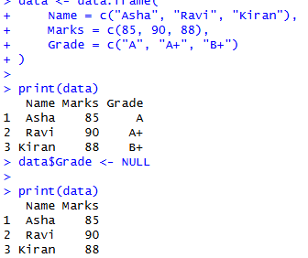

- Renaming Columns:
names(data)[names(data) == &quot;old&quot;] &lt;- &quot;new&quot;
output:
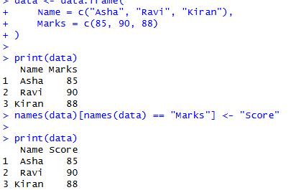

- Filtering Rows:
data &lt;- subset(data, age &gt; 20)
output:
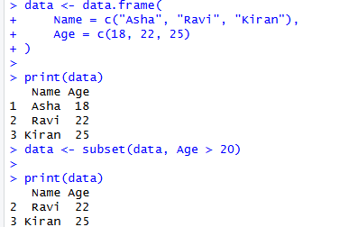

- Updating Values:
data$age[data$age &lt; 18] &lt;- 18
output:
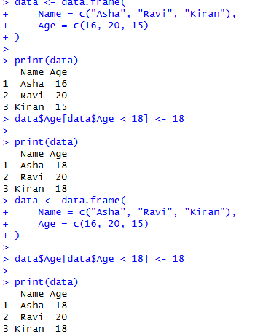

4. Useful Tips and Best Practices in R (RStudio)
These are useful commands and examples.

1. Check the Current Working Directory
Program
getwd()
Output (Example)
[1] "E:/New folder"

2. Change the Working Directory
Program
setwd("E:/New folder")
Verify
getwd()
Output
[1] "E:/New folder"

3. Prevent Automatic Factor Conversion
Program
data <- data.frame(
Name = c("Asha", "Ravi"),
Grade = c("A", "B"),
stringsAsFactors = FALSE
)

print(data)
Output
Name Grade
1 Asha A
2 Ravi B

4. Read Large Files Faster (data.table)
Install the package (only once)
install.packages("data.table")
Program
library(data.table)

data <- fread("E:/New folder/student.csv")

print(data)
Output (Example)
Name Marks
1: Asha 85
2: Ravi 90

5. Write a CSV File Using write.csv2()
Program
data <- data.frame(
Name = c("Asha", "Ravi"),
Marks = c(85, 90)
)

write.csv2(data, "E:/New folder/output.csv", row.names = FALSE)
Result: The file output.csv is created in E:\New folder.

Summary
Function | Purpose
getwd() | Displays the current working directory
setwd() | Changes the working directory
stringsAsFactors = FALSE | Keeps text columns as character values
fread() | Reads large CSV files quickly
write.csv2() | Writes CSV files using regional formatting (e.g., semicolon separators where commas are decimal separators)

